**Problem Statement:**

There is an employee demographic file which contains name, address, postal code. Postal codes could be incorrect as per the address. Need to validate the address, transform and create a new file for staging.

**Solution**

1. Read the employee csv file from s3 bucket. Put it into an ordered Dict. Ordered Dict will take care of the header of csv as well.
2. Take the address from dictionary and pass it to Google API to get the exact address along with proper postal code

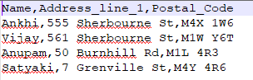

Data from Google API will be in json format.

API used : "https://maps.googleapis.com/maps/api/geocode/json"

1. Take the postal_code from this json and update in the dictionary.
2. Write the data of Dictionary into another file in S3.

